AP233 Planning

Scope statement for Behaviour (BEH) Modules

Configuration Control
Version | Date | Author, Update trail
1 | 4/11/2002 | JFE Johnson, initial version
2 | 1/22/03 | DW Oliver
3 | 2/4/03 | Mike Dickerson
4 | 30/6/03 | AP233 group at INCOSE IS 2003

Context
Existing work in Modular-AP233 development has progressed the Text-Based and Property Based Requirements Modules, as a way of supporting the various forms of requirements expressions in conventional requirements documents. A Structure Module set has been initiated to support structure and analysis aspects of the modelling of requirements.
The Behaviour Module set supports the modeling of what a system is to do. There are two distinct forms or parts of the Behavior module set currently identified. One of these is behavior represented with state. This is a discrete approximation to behavior. The second part is Function Based Behavior based on functions, and function ordering, and is independent of state. The requirement below lists examples of specifically named notations recognisable by systems engineers.
The semantic material that is represented by these forms is the focus of this Module. For example, it is important to be able to extract from a data flow diagram the associated process and data specifications that capture the inherent semantic information. Presentation information will be addressed by a different module set, Data Presentation, since it is desirable that presentation information is captured such that the native diagrams can be reproduced.
State Based Behavior Module Set, SBB
This module set supports behavior representations such as Data Flow Diagrams, State Charts, Moore Extended State Machines, and Mealy Extended State Machines. These representations are supported by a group of tool vendors, most of whom are participating in the refinement of UML 1.4 to UML 2.0. It is expected that the tools will become compliant with that standard. In consequence, AP233 will also adopt map to that standard for State Based Behavior. The work to be done is to obtain the standard adopted by OMG for UML 2.0 and to convert it to equivalent EXPRESS modules. Tools like Statemate Magnum may not be UML 2.O compliant. These type of tools will still have to covered by state based behaviour.

Function Based Behavior Module Set, FBB
This module set supports behavior representations such as N-Squared Charts, CORE EFFBD’s (behavior diagrams), Functional Flow Block Diagrams, BAE SYSTEMS CoRE Thread Diagrams,
relevant IDEF Diagrams , hierarchy and Scripts.

Exclusions from the BEH Module Sets
Engineering design diagrams such as logic diagrams, geometric drawings, petri nets, Truth Tables, activity diagrams analysis equations, and control block diagrams are excluded. These should be added in additional modules.
NOTE: Further practical examples need to be gathered to support the general statement of requirements for this module.

Other module set: There is a posssiblity to add extensions to semantics for additional user defined capability. This has to be looked at as a possible solution. E.g. Bruce Douglass UML models.

Related work
Work to create this module would need to assess the requirements for this module, and evaluate existing modules and their elements, for relevance.
This work should assess the relevance of any material in AP210 (AP212?), which (?) addresses some aspects of product functionality.
The developer needs to be aware that there is an ongoing dialogue with the parallel activity to develop support for Systems Engineering in UML (SE DSIG) to assess the requirements and coverage of behaviour support in AP233 with respect to what is emerging from the UML 2.0 proposals.

Requirements on SBB and FBB Modules
- The data model must be able to capture in a semantic form, information that is traditionally represented in various notations currently widely used by systems engineers in this domain which include, but are not limited to: data flow diagrams (& mini specs), Functional Flow Block Diagrams (FFBD), state transition diagrams, statecharts, activity diagrams, N² charts, IDEF diagrams, , pseudocode, the notations of UML 2.0 that in any way capture product behaviour.
- The semantic content with the source material of a behavioural specification in its native form, when expressed via the SBB or FBB data model, must be re-representable in a way semantically indistinguishable from the original source material, as far as possible.
- , SBB or FBB when used with (a complete) data representation module, is about supporting the movement of behavioural specifications from one engineering tool to another, including the reproduction of the diagrams used to represent such specifications. However, SBB or FBB and the data representation module should make it possible that reproduction of approximate representations (that remain semantically consistent), and that are recognisably similar to the originals, can be produced. It is not expected that the structured diagrams (listed in FBM1) can be reproduced verbatum. For instance, it is not necessary that a Ward-Mellor data flow diagram is reproduced with same font labels, arrow styles, and exact placement (in the way a PDF conversion of a Word document tightly reproduces the original). However, it is important that arrows (representing flows) touch ('connect') circles representing transforms, and that the arrow is indicated in the correct direction to reflect the sense of the flow. It is important that the relative placement of major graphic elements (circles, arrows) are recognisably similar on the generated diagram as on the original.
- The module concepts should be built on existing STEP Modules where possible.

Issues
- The scope of this module should address the needs for representation of systems characterised as exhibiting both discrete and continuous behaviour, and covering both information systems and material processing systems.
- The module developer will need to be aware that at times there are extensions by individual tools / vendors to 'standard' notations, with corresponding semantic extensions, for their individual business objectives. The AP233 group will need to assess such extensions as to whether they are incorporated into FBM/AP233 or not.
- To tackle the reproduction of the function based and state based diagrams used by systems engineers, this work will also need to tackle, in some way, the data model scope anticipated by the Intelligent Schematics PWI, at least in so far as capturing the relationships between diagram types and corresponding semantics. The support in the SEDRES Working Draft#5 was found to be a minimum capability in this area.

References
Structured Analysis and System Specification, Tom DeMarco, 1978
Ward & Mellor series on Real Time Structured Specifications, circa 1984
INCOSE SE Handbook
EIA 632 Processes for Engineering a System
ISO 15288 System Life Cycle Processes, 2001?
SEDRES Working Draft #5 (PAS), 2001.

Specific fragment from EIA 632
Requirement 17—Logical Solution Representations
The developer shall define one or more validated sets of logical solution representations that conform with the technical requirements of the system.
The developer should plan and do appropriate tasks to complete this requirement. Tasks to consider include the following:
a) Select and implement one or more appropriate approaches to providing an abstract definition of the solution to the system technical requirements. For the approaches selected, complete the appropriate tasks from (b) through (d) below that aid in defining logical solution representations.
NOTE—Functional analysis, object-oriented analysis, structured analysis, and information engineering, analysis are recognized approaches found in text books and other literature to develop logical solution representations in terms of, for example, functional flows, behavioral responses, state and mode transitions, timelines, control flows, data flows, information models, object services and attributes, context diagrams, threads, data structures, and functional failure modes and effects.

Example tools that support the modelling of this domain
Tool | Vendor
CORE | Vitech
Statemate | i-Logix
Software Through Pictures | Aonix
CRADLE | ThreeSL
RDD-100 | Halogent
Teamwork | Computer Associates
System Architect | Popkin
MATLAB/Simulink | Mathworks
SABRE | ?
The following examples show examples of the notations supported by several of the above tools, more material may be available, and specific references to publications documenting some of these formats can be provided.
Example from Statemate
This is a notation called an activity chart, which is a hierarchical dataflow diagram, and is analogous to an hierarchical state transition diagram or statechart (Harel et al).
It does not follow style of transformation labelling (verb noun) that is good practice for data flow diagrams.
Example from Teamwork
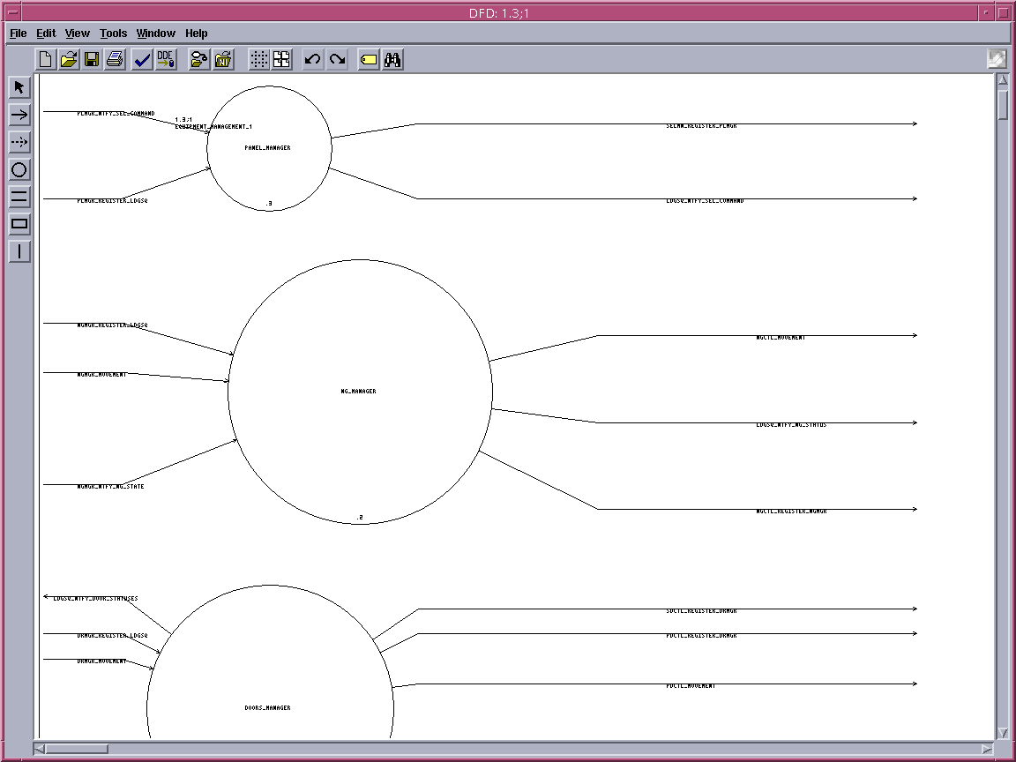
This is an example of a traditional data flow diagram, from Teamwork.
It does not follow style of transformation labelling (verb noun) that is good practice for data flow diagrams.

Example from MATRIXx
This is an example of a control block diagram, from the tool MATRIXx. This tool is being superceded by a different tool MATLAB (MATLAB notation example was not available).
There were some problems with the import interface from this diagram, when the specification was inported, hence some peculiarities with the layout.
Example from Software Through Pictures

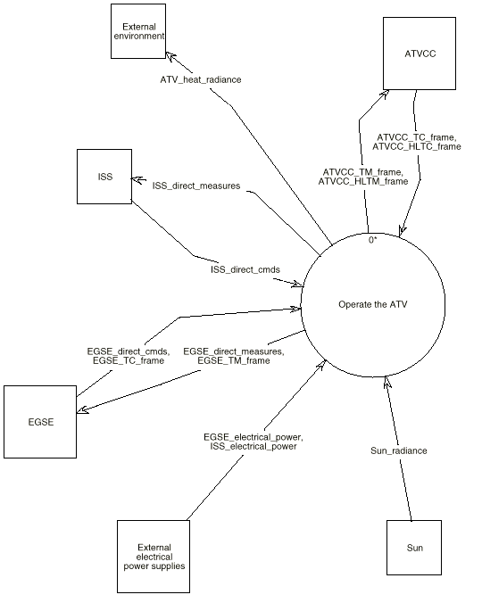
This is an example of a context diagram from Teamwork. Next level of detail would be a DFD0, which would have the same functional interface as appears in this diagram.
Example from DOORS

This example from DOORS illustrates a presentation of mapping between functional and requirements information, (one assumes) used to illustrate that some functional requirements have been allocated to some functions. The diagram is ambiguous without more information, as it could equally well be interpreted to represent that specific functions fulfil particular requirements (a different meaning).

